--- PRESS RELEASE ---
09.07.2025

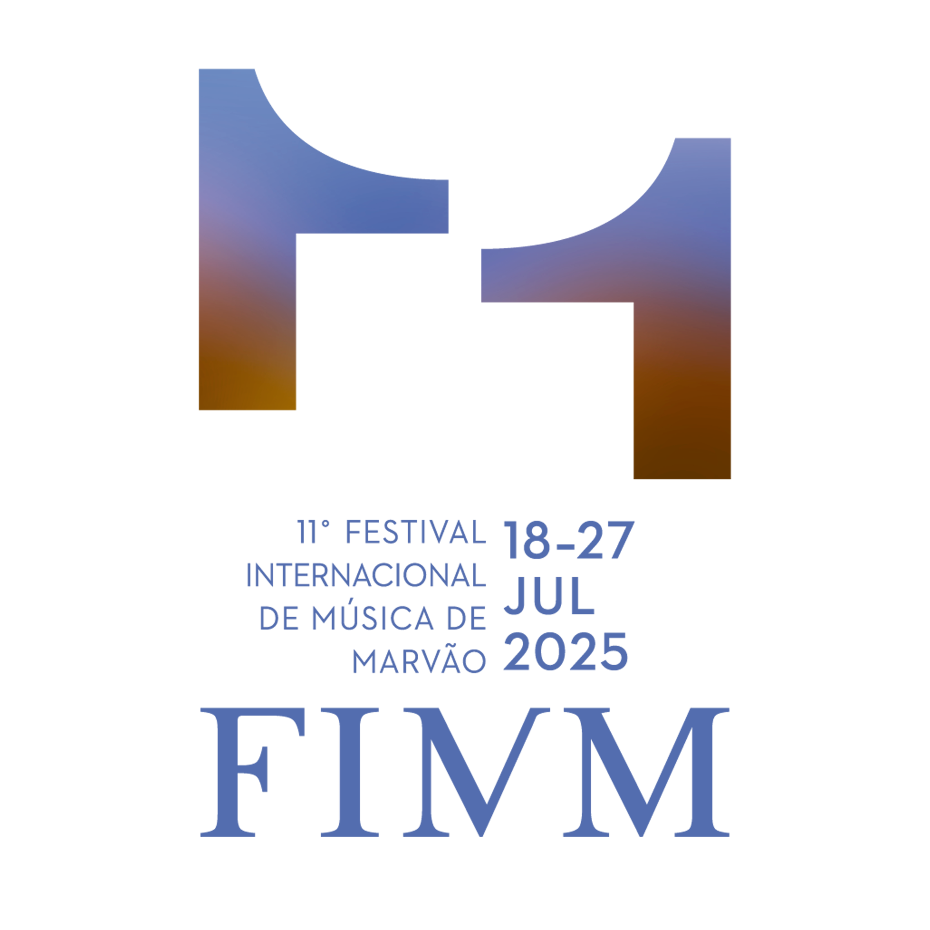

11º MARVÃO INTERNATIONAL MUSIC FESTIVAL
Artistic Direction: Juliane Banse & Christoph Poppen

18 – 27 JULY 2025

The Marvão International Music Festival (FIMM), organised by the non-profit association Marvão Music, returns from 18 to 27 July 2025 for its 11th edition. More than 15,000 visitors are expected for this celebration of classical music and heritage, set against one of the most inspiring landscapes in Portugal.

Almost 40 activities are planned over the 10 days of the festival, including concerts, open rehearsals, events for children, art exhibitions, guided tours and more. These initiatives aim to enrich the visitor experience by highlighting the natural, cultural and historical resources of Marvão and the Serra de São Mamede Natural Park, in collaboration with a wide network of local and international partners.

After a landmark edition in 2024 – marked by the premiere of its first in-house opera production at Marvão Castle, Die Entführung aus dem Serail by W. A. Mozart – the festival begins its second decade with a proposal that is both intimate and bold, featuring a programme almost entirely dedicated to chamber music.

The successful structure developed over the years remains in place, with open-air concerts in the late afternoon in the courtyard of Marvão Castle, as well as performances throughout the day and evening in iconic locations such as churches, the castle’s cistern, and the ruins of the Roman city of Ammaia. As usual, some of these events will be free of charge.

Chamber music, with its shared breath among performers (many of whom meet and play together for the first time), its closeness to the audience, and the human scale of its works – heightened by the character of the venues – will be the heart of the programme. Listening to Beethoven’s quartets, Debussy’s sonatas or Schönberg’s duos means entering a world of detail and intensity, where nothing is superfluous.

Over ten days, the festival presents “musical portraits” of 25 composers, bringing together leading names of the European canon (Tchaikovsky, Ravel, Brahms), important but often overlooked female composers (Lili and Nadia Boulanger), contemporary authors such as Wolfgang Rihm and Luís Tinoco (Prémio Pessoa 2024), and figures associated with silence and dissonance, like Webern and Pärt, among others who defy conventional classification. One of the highlights will be a tribute to Wolfgang Rihm, marking exactly one year since his passing.

FIMM also continues to embrace new audiences and musical languages. The programme includes the Jazz Night BPI | Fundação “la Caixa” featuring Maria João & Mário Laginha, as well as a fado concert with Ana Margarida Prado – both set in unique venues such as the Roman ruins of Ammaia and the castle’s cistern.

Among many other highlights are the special concert by Christoph and Julian Prégardien – father and son – offering a rare moment of vocal intimacy, and a new edition of the Marvão Festival Chorus (MFC), participatory project, conducted by Maestro Pedro Teixeira.

Many of the concerts will be fully recorded and, as in 2024, later made available on the free streaming platform CaixaForum+, as part of a major project supported and produced by K&T and Fundação “la Caixa”.

The parallel programme includes an exhibition of Portalegre Tapestries at the São Tiago Church and an art installation by Vasco Araújo in the Keep of the Castle, supported by the António Cachola Collection and in partnership with the Museum of Contemporary Art of Elvas (MACE).

Tickets for FIMM grant free access to the Museum of Contemporary Art of Elvas for one year, as well as to the Roman City of Ammaia and its Museum until the end of September 2025.

The Marvão Festival’s Principal Sponsors are Banco BPI | Fundação ”la Caixa” and the German foundation Anja Fichte. It is also supported by Turismo de Portugal, bp Portugal, and Stone Capital.

(Full list of partners HERE)

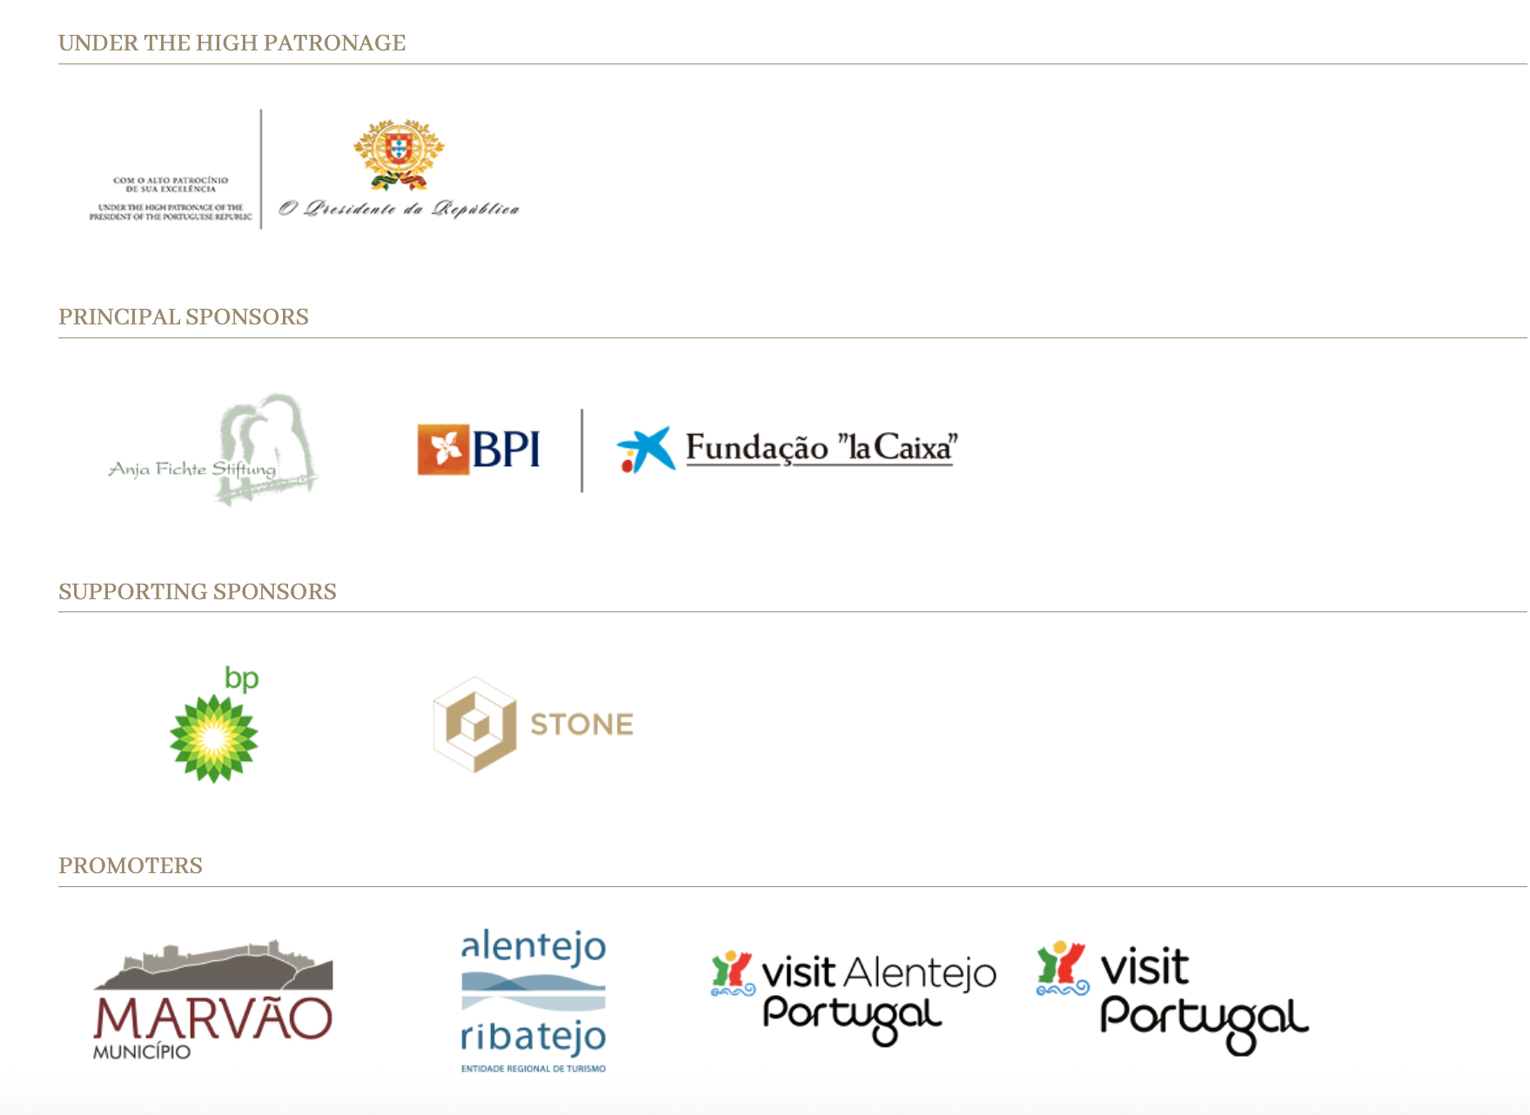

PROGRAMME and highlights

- 32 chamber music concerts
- 2 choral concerts
- 1 sung mass
- 1 jazz concert
- 1 fado concert
- concerts and open rehearsals for young audiences and children
- art exhibitions and other parallel events
- guided tours
- Programming in emblematic sites of the region, including the Roman Ruins of Ammaia and Marvão Castle – both classified as National Monuments

- A diverse and eclectic programme, spanning several styles and periods: Renaissance, Baroque, Classical, Romantic, Contemporary music, Fado and Jazz

- Featuring hundreds of artists from around the world

- Strong participation by Portuguese artists

- Participatory project of the Marvão Festival Chorus, bringing together professional singers and high-level amateurs of various ages and nationalities, culminating in a public final concert

- SOME CONFIRMED ARTISTS: Aaron Pilsan, Adrien La Marca, António Saiote, Bruno Philippe, Christoph Poppen, Christoph Prégardien, Clara-Jumi Kang, Horácio Ferreira, Julian Prégardien, Juliane Banse, Maat Saxophone Quartet, Malion Quartett, Maria João & Mário Laginha, Officium Ensemble, Pavel Kolesnikov, Quatuor Arod, Silke Avenhaus, Sunhae Im, Sunwook Kim, Tae-Hyung Kim, Teresa Sales Rebordão… AMONG MANY OTHERS

TICKETS
- Tickets from €25.00 (50% discount for permanent residents of the municipality of Marvão)

FIGURES
- Approximately 15,000 visitors expected from Portugal and around the world
- Nearly 40 concerts and other events over 10 days
- Around 25% of the events are free to attend and participate in
- More than 60 institutional partners, both Portuguese and international, supporting this edition

ADDITIONAL INFORMATION

- Mobile app available for Android and iOS with the full programme, information, and useful features, including accommodation details
- Tickets available at Ticketline.pt and partner outlets, including Worten and Fnac stores. Limited capacity: early purchase of valid tickets is recommended
- Press accreditations available at
https://marvaomusic.com/en/press-accreditation/

PRESS PHOTOS
- Free to use. Credits: ©FIMM / Paulo Gouveia & Estela Álvarez Ruiz
Access and download HERE.

PRINCIPAL SPONSORS
Anja Fichte Stiftung, BPI | Fundação ”la Caixa”

SUPPORTING SPONSORS
bp Portugal, Stone Capital

OTHER SPONSORS AND SUPPORTERS
A MatosCar, VOLVO Portugal, Delta, Super Bock Group

PROMOTERS
- Under the High Patronage of His Excellency the President of the Republic
- Marvão Municipality
- ARPTA – Alentejo Regional Agency for Tourism Promotion

OTHER HIGHLIGHTS OF THIS ANNUAL FESTIVAL

- Organised by the Marvão Music Association, officially recognised as a Public Utility Entity
- Winner of the BEST EVENT award (2017) and Honourable Mention (2018) at the Alentejo and Ribatejo Tourism Awards
- Winner of the MOST INITIATIVE category (public vote) at the Mais Alentejo magazine gala (2018)
- Awarded the EFFE Label (Remarkable Arts Festival / Europe for Festivals, Festivals for Europe) for 2019–20, 2022–23 and 2024–25 – a European mark of quality for outstanding arts festivals, recognising artistic commitment, community involvement and international outreach
- Nominated in various public vote categories at the Iberian Festival Awards since 2019, including Best Tourism Promotion, Best Small Festival, and Best Video Coverage, among others.

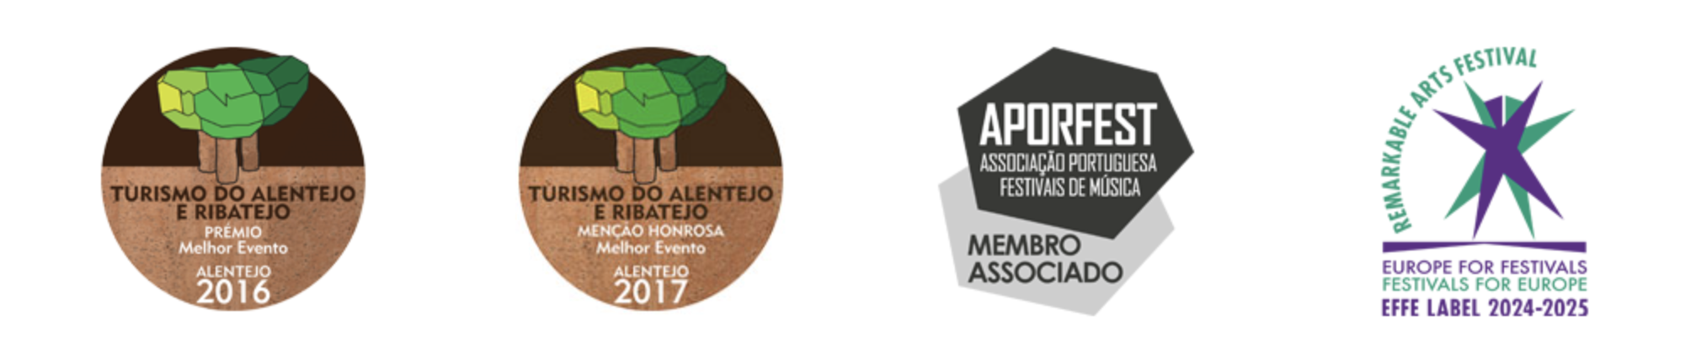

SOME FACTS ABOUT THE MARVÃO VILLAGE
- Fewer than 100 permanent residents
- The highest village in Portugal
- Located at the top of the Serra do Sapoio, at an altitude of 860 metres, within the São Mamede Natural Park
- Seat of a municipality with around 3,000 inhabitants
- Situated near the Spanish border, approximately 2.5 hours from Lisbon
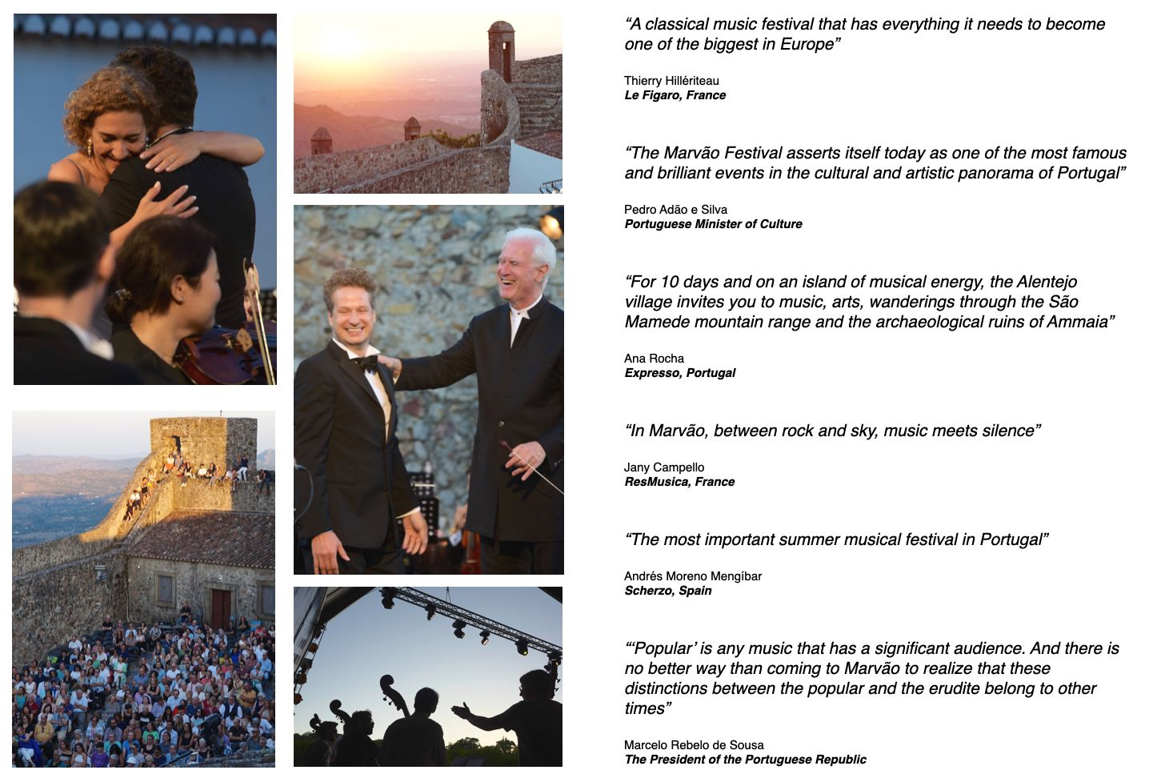
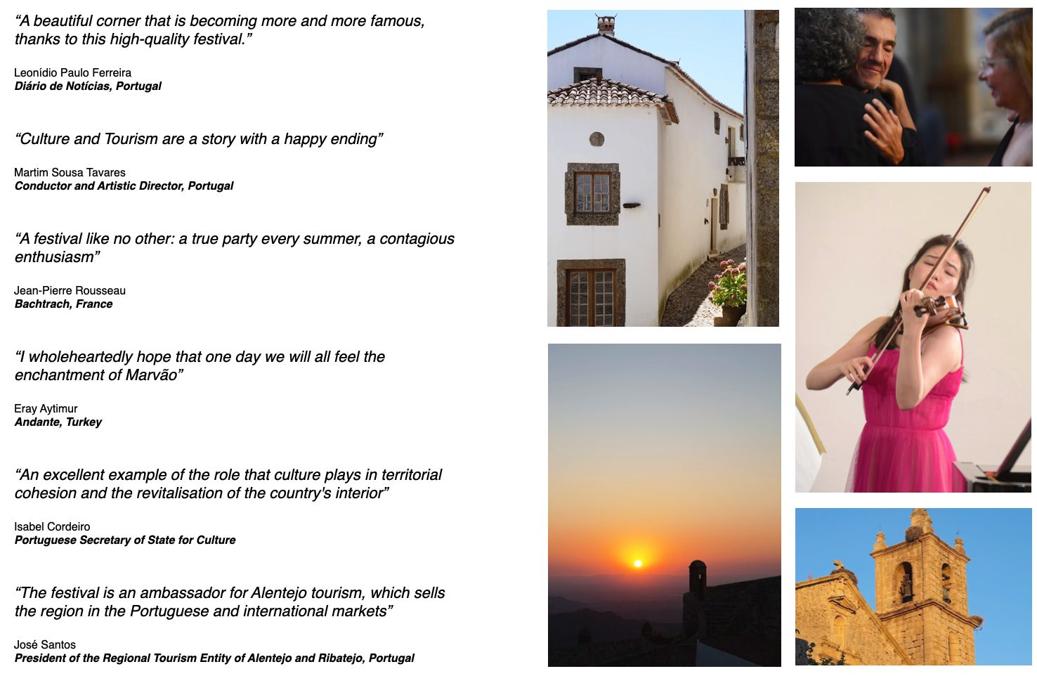

MORE INFO: marvaomusic.com

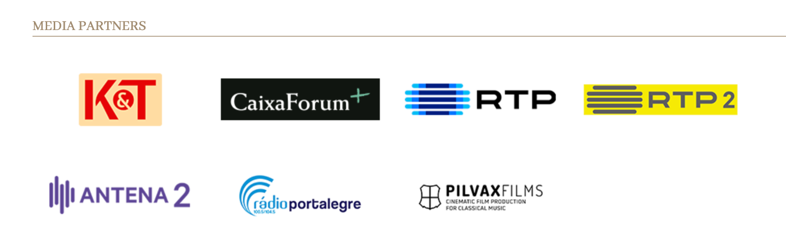

CONTACTS:

info@marvaomusic.com
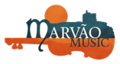
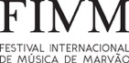
https://marvaomusic.com/en/for-press/

